Arduino Lesson 19
Infrared Remote Control
- Intro
What is an infrared receiver？
Infrared remote controller send out the signal consist of a serial Binary pulse code. In order to avoid interference from other infrared signal while the wireless transmission, usually modulate the signal on specific carrier frequency, and then launch out by the infrared emission diode.
The infrared receiving device need to filter out other clutter, then receives the specific frequency signal and restore it into binary pulse code, i.e demodulation.
Theory
Built-in receiving diode will convert the light signal into a weak electrical signal, the signal will be amplify while it pass the internal amplifier inside IC, and then restore to the original codes through the automatic gain control, band-pass filtering, demodulation, waveform shaping processes, codes go to code identify circuit by receiver’s single output pins.
Pins and wiring (as below picture shown)
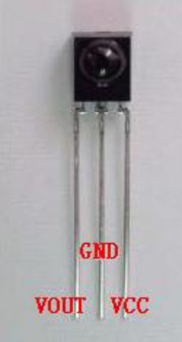
Access VOUT to analog interface, GND to Arduino GND, VCC to Arduino +5v
- Parts Required
 Infrared remote controller x 1
 Remote Receiver x 1
 LED light x 6
220Ω Resistor x 6
 Jumper wires x 1 Bundle
- Connect-it-up
Connect Arduino and infrared receiver as above method, put VOUT pin to digital interface #11, connect LED to digital pin 2,3,4,5,6,7 through resistors.
Before decoding, we need to know the remote controller’s coding scheme.The controller you bought use NEC protocol.

·NEC Protocol Features
（1）8-bit address bit, 8-bit command bit
（2）address bit and command bit are transferred twice for reliability
（3）pulse position modulation(PPM)
（4）carrier frequency 38khz
（5）time/bit is 1.125ms or 2.25ms
·Logic 0 and 1 definition as below picture shown
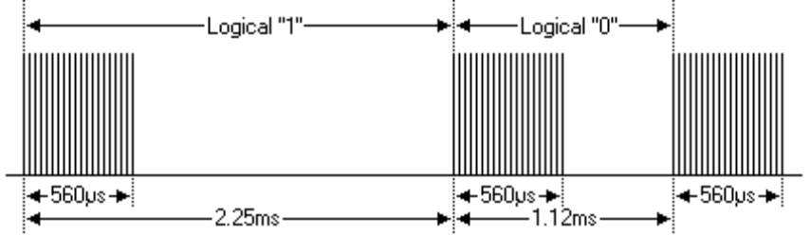
Protocol as below
·Launched pulse when the button is pushed and released at once 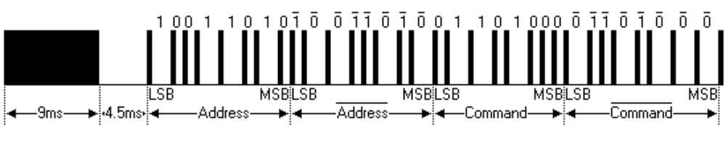
The above picture shows the NEC protocol typical pulse sequence. Note: The LSB (least significant) protocol is sent first, transfer address is 0 x 59,command is 0 x 16.One message is start with a 9ms high level, come with a 4.5ms low level(return 2 level to consist of the lead code), then transfer twice by address bit and command bit.Second time all bits are negation, this is to confirm to use the message received. Total transfer time is fixed as every point is repeated with the negation length. If you are not interested in it, you can ignore this reliability negation and expend the address and command instead(i.e launch pulse when button is pushed for a while and released with every 16 bits.)

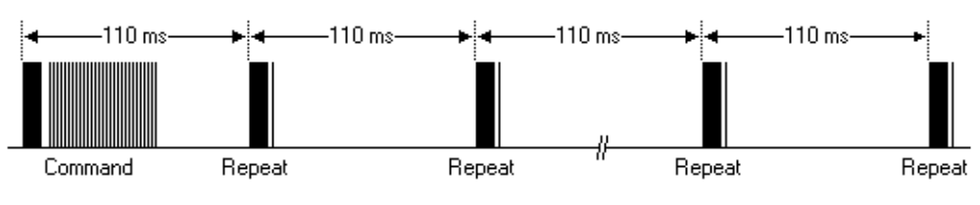
One time for one command and remain the button pushed. When the button remain pushed status, the first 110ms pulse same as above picture, every 110ms repeat and transfer the code. Returned repeat code is consist of a 9ms high level pulse, a 2.25ms low level and a 560μs high level。
·Repeat pulse
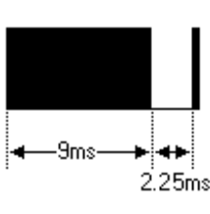
Note: The integration infrared receiver need to decode, signal amplify and shape after the pulse waveform get in, Note: Without the infrared signal, its output is high level, become low level when signal come in, so the output signal level is opposite of the transmitter. Receiving end pulse e can be see through the oscilloscope, get to understand the programming.

Remote controller Key Assignments:
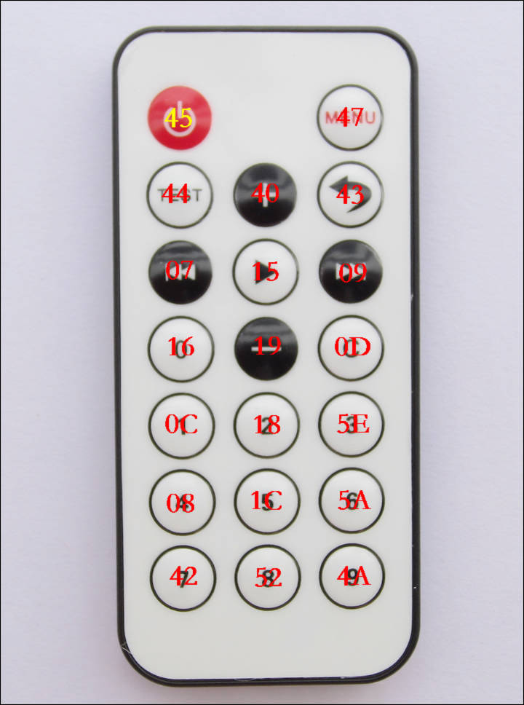
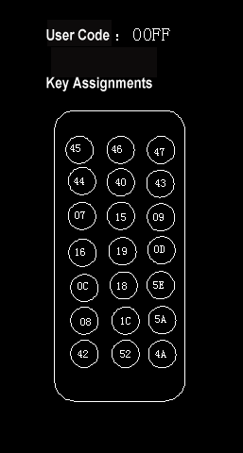

Row1-1 = 0x00FFA25D; Row1-2 = 0x00FFE01F; Row1-3 =0x00FF629D;
Row2-1 = 0x00FFA857; Row2-2 = 0x00FFE21D; Row2-3 = 0x00FF906F;
Row3-1 = 0x00FF22DD; Row3-2 = 0x00FF6897; Row3-3 = 0x00FF02FD;
Row4-1 = 0x00FF9867; Row4-2 = 0x00FFC23D; Row4-3= 0x00FFB047;

- Program for reference
#include <IRremote.h>
int RECV_PIN = 11;
int LED1 = 2;
int LED2 = 3;
int LED3 = 4;
int LED4 = 5;
int LED5 = 6;
int LED6 = 7;
long on1 = 0x00FFA25D;
long off1 = 0x00FFE01F;
long on2 = 0x00FF629D;
long off2 = 0x00FFA857;
long on3 = 0x00FFE21D;
long off3 = 0x00FF906F;
long on4 = 0x00FF22DD;
long off4 = 0x00FF6897;
long on5 = 0x00FF02FD;
long off5 = 0x00FF9867;
long on6 = 0x00FFC23D;
long off6 = 0x00FFB047;
IRrecv irrecv(RECV_PIN);
decode_results results;
// Dumps out the decode_results structure.
// Call this after IRrecv::decode()
// void * to work around compiler issue
//void dump(void *v) {
// decode_results *results = (decode_results *)v
void dump(decode_results *results) {
int count = results->rawlen;
if (results->decode_type == UNKNOWN)
{
Serial.println("Could not decode message");
}
else
{
if (results->decode_type == NEC)
{
Serial.print("Decoded NEC: ");
}
else if (results->decode_type == SONY)
{
Serial.print("Decoded SONY: ");
}
else if (results->decode_type == RC5)
{
Serial.print("Decoded RC5: ");
}
else if (results->decode_type == RC6)
{
Serial.print("Decoded RC6: ");
}
Serial.print(results->value, HEX);
Serial.print(" (");
Serial.print(results->bits, DEC);
Serial.println(" bits)");
}
Serial.print("Raw (");
Serial.print(count, DEC);
Serial.print("): ");

for (int i = 0; i < count; i++)
{
if ((i % 2) == 1) {
Serial.print(results->rawbuf[i]*USECPERTICK, DEC);
}
else
{
Serial.print(-(int)results->rawbuf[i]*USECPERTICK, DEC);
}
Serial.print(" ");
}
Serial.println("");
}

void setup()
{
pinMode(RECV_PIN, INPUT);
pinMode(LED1, OUTPUT);
pinMode(LED2, OUTPUT);
pinMode(LED3, OUTPUT);
pinMode(LED4, OUTPUT);
pinMode(LED5, OUTPUT);
pinMode(LED6, OUTPUT);
pinMode(13, OUTPUT);
Serial.begin(9600);

irrecv.enableIRIn(); // Start the receiver
}

int on = 0;
unsigned long last = millis();

void loop()
{
if (irrecv.decode(&results))
{
// If it's been at least 1/4 second since the last
// IR received, toggle the relay
if (millis() - last > 250)
{
on = !on;
// digitalWrite(8, on ? HIGH : LOW);
digitalWrite(13, on ? HIGH : LOW);
dump(&results);
}
if (results.value == on1 )
digitalWrite(LED1, HIGH);
if (results.value == off1 )
digitalWrite(LED1, LOW);
if (results.value == on2 )
digitalWrite(LED2, HIGH);
if (results.value == off2 )
digitalWrite(LED2, LOW);
if (results.value == on3 )
digitalWrite(LED3, HIGH);
if (results.value == off3 )
digitalWrite(LED3, LOW);
if (results.value == on4 )
digitalWrite(LED4, HIGH);
if (results.value == off4 )
digitalWrite(LED4, LOW);
if (results.value == on5 )
digitalWrite(LED5, HIGH);
if (results.value == off5 )
digitalWrite(LED5, LOW);
if (results.value == on6 )
digitalWrite(LED6, HIGH);
if (results.value == off6 )
digitalWrite(LED6, LOW);
last = millis();
irrecv.resume(); // Receive the next value
}
}

Decode the coded pulse from the remote controller and execute according to the decoded result. Then you can control you device and make it listen to your command!

